Instructions for loading dissertation titles on APA.U.DP.GRAD.INFO

- Access the student record through APA.U.DP.GRAD.INFO, select the specific doctoral Program of Study (POST code), and proceed to page 3.

- 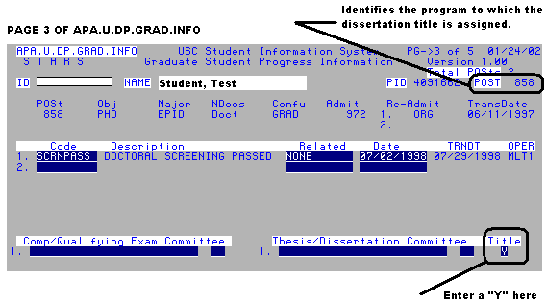Position the cursor in the “Title” field in the lower right hand corner of page 3 and type a “Y”, as illustrated below.

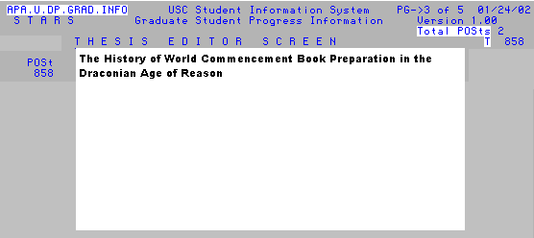3. Enter the dissertation title in the ‘THESIS EDITOR SCREEN’ window, using upper and lower case characters as appropriate. Please try to scroll down when you are finished typing (use the “down arrow” key, not “Enter”) to check for stray characters or extra lines of information. If you find any, use “Backspace” to remove them.

4. Exit the window (F8 or Esc, Esc, Q command) and update the record. The title will appear in the commencement book as entered on APA.U.DP.GRAD.INFO. You will have an opportunity to indicate italics and special characters when the first draft of the commencement book is distributed to coordinators (usually in early March).

